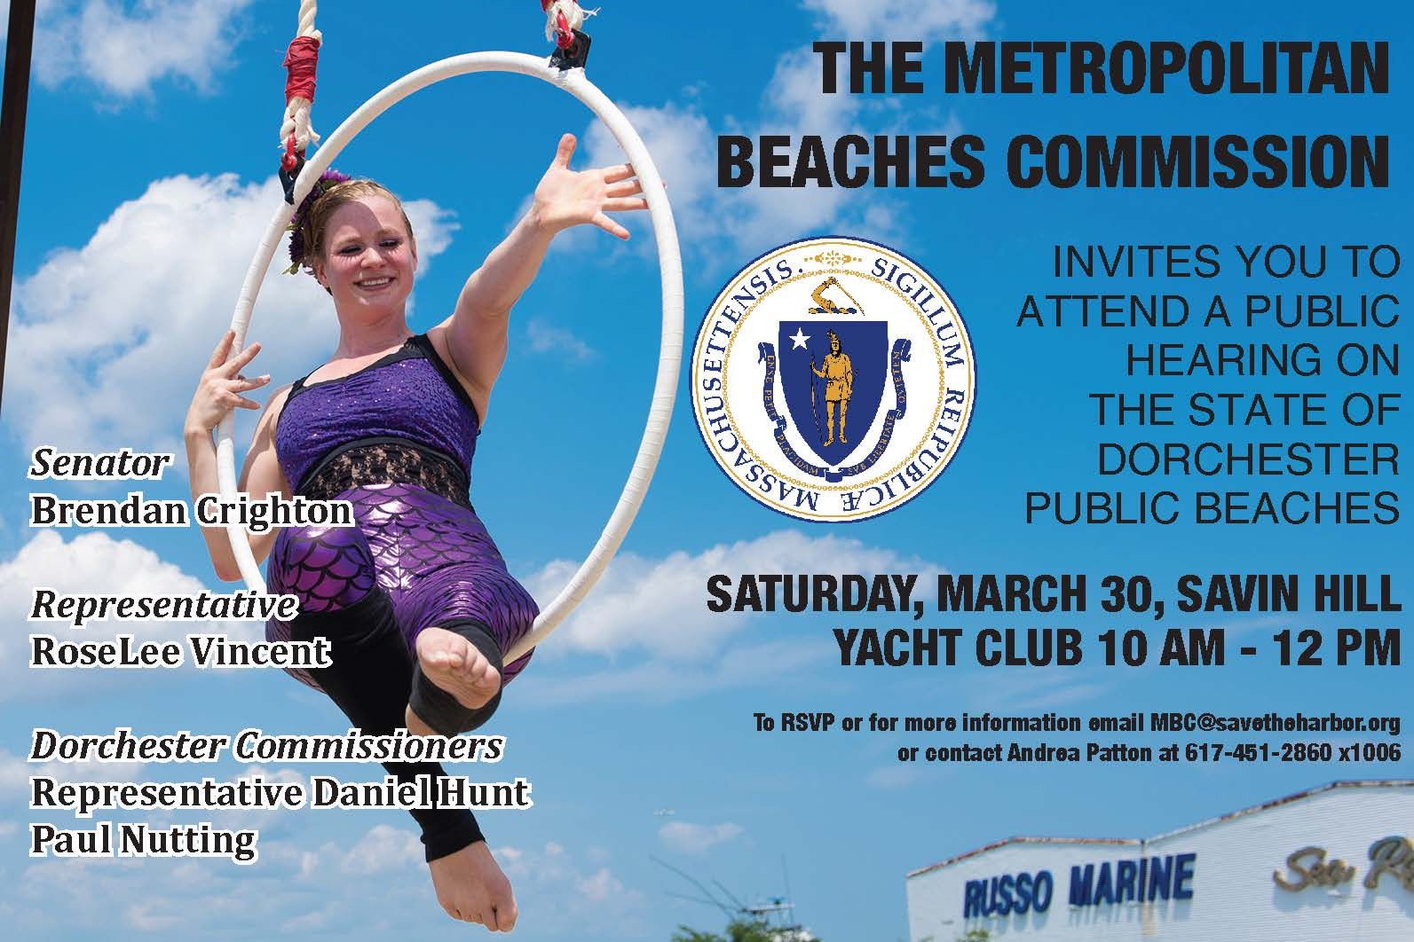

Environmental Concerns
- Participants appreciate the great water quality at Savin Hill and Malibu Beach.
- Multiple participants did express a desire for a dredging project in the bay, as water depth has decreased and the beach feels more like swampland each year.
- There was unanimous concern regarding the water quality challenges at Tenean Beach and a strong desire to see the resources put behind fixing the issues.
- Similar consensus existed regarding the extreme displeasure residents feel regarding the use of Victory Road Park by professional dog walkers and the environmental harm that significant dog waste at the site has created.

Upkeep, Maintenance, and Capital Investments
- The hearing included much discussion of DCR’s efforts to steward Savin Hill/Malibu; some participants felt that the staff do a good job sweeping the boardwalk, removing sand from the stairs and ramps, and cutting grass. Others felt that the staff doesn’t feel present and doesn’t do enough to clean the boardwalk or pick up trash.
  - Residents of Port Norfolk feel that Tenean Beach is well maintained and kept up from the water, through the parking lot, and to the tennis courts.
- Groups questioned why there are no longer lifeguards stationed at Savin Hill/Malibu
- There was a universal call for more trash barrels, with covers, and more frequent trash pick ups at all Dorchester Beaches;
  - Residents also noted that there is frequently a great deal of litter in the parking lot at Savin Hill that is never collected.
  - Concerns were also expressed about the local yacht clubs’ contribution to debris problems and how to best cooperate on mitigation and clean up.
- Capital projects requested included sand renourishment - and specifically cleaner, finer sand -at Savin Hill, dredging at Savin Hill, construction of bathrooms on the Savin Hill side, and a continuation of the boardwalk all the way around the reservation, and finally a bathhouse at Tenean Beach.

Transportation
- Beach lovers appreciate the readily available parking at all Dorchester beaches.
- Folks appreciate the connection to the Neponset Greenway and would like to see the pathway completed.
- Groups were intrigued to hear about the proposal to create a ferry service from Squantum Point Park in Quincy to the UMass Boston pier in Dorchester, as well as ideas to bury Morrissey Blvd and create a seamless park.

Activities and Amenities
- Participants appreciate the new playground at Tenean Beach.
- Attendees love the festivals that have been taking place, and would like to see more large scale community events.
- Beach lovers would also like to see more smaller scale events and programming including swimming lessons, kayaking rentals, sailing programs, and improvement to the volleyball courts at Savin Hill for more events there.
- Participants would also like to see more amenities especially food through concessions, food trucks, or regular farmers markets.
- Residents would love to see better promotion of these neighborhood beaches so that community members don’t feel like they have to drive to get to the ocean.

