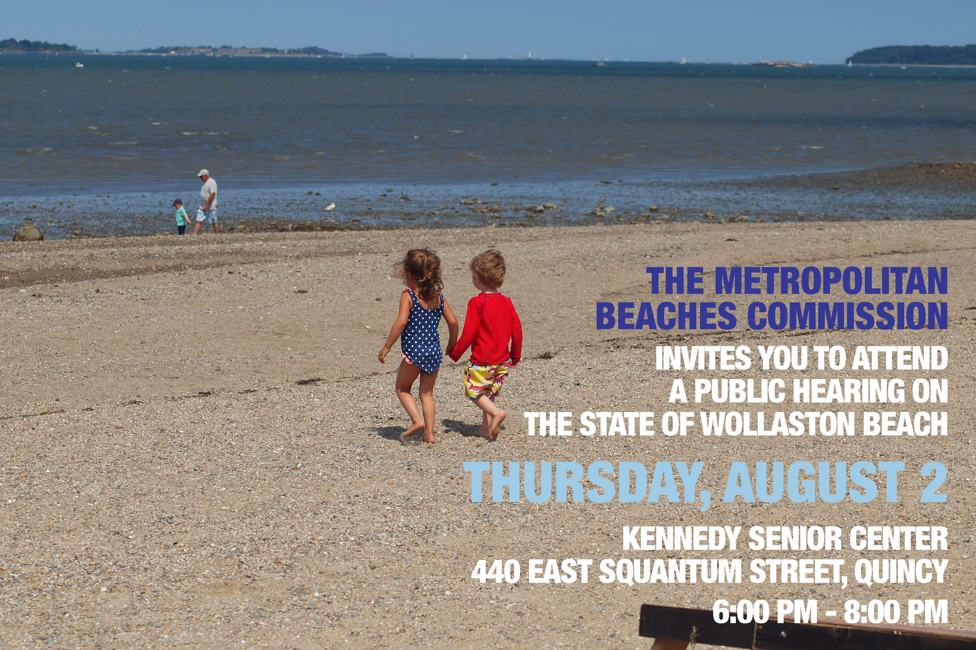

Needs and Opportunities
- Noise and safety– while much improved, some concerns remain over safety at night and loud noise from traffic and loud music.
- Dogs and dog waste are still a problem.
- Trash and recycling barrels, including the solar compactor style that seagulls can’t get into, and more regular emptying of the barrels are needed.

Capital Improvement
- Concerns raised regarding confidence in sewer system and particular outfall pipes.
- Need for better upkeep of recent capital improvements including the seawall

Events and Programs
- Programs and events are some of the best things about the beach. Additional events such as movie nights, and adult-oriented events such as dance lessons were suggested.
- Need a centralized place to communicate everything happening at Wollaston.

Connections and other Initiatives
- Walking paths and pedestrian access are excellent. Some walking paths could be extended and sidewalks improved.
- While the beach is somewhat bike friendly, there is need for more bike racks, bike sharing, and a dedicated bike lane on Quincy Shore Drive.
- More robust public communication about the water quality improvement is necessary.
- Sand, while well maintained and groomed by DCR, is increasingly rocky. Efforts to remove of sand from Quincy Shore Drive after the winter storms was praised, although a few remaining areas were highlighted. Longer term issues of erosion, shallow tidal zones as sand gets pulled out, and a need for dredging to retain access to the Yacht Club were also mentioned.

Amenities
- Existing amenities such as restaurants and restrooms were highly praised.
- Additional vendor amenities including umbrella and chair rentals, kayak rentals, and food trucks and/or push carts especially at the north end of the beach were requested.
- Aesthetic improvements including more shady spots, more seasonal plantings, and better maintenance of grass beds are needed.

Staffing
- Most attendees praised Wollaston Beach’s Beach Manager by name.
- Lifeguards were also praised as going above and beyond to steward the beach.
- A need for more lifeguards at the north end of the beach was expressed.

