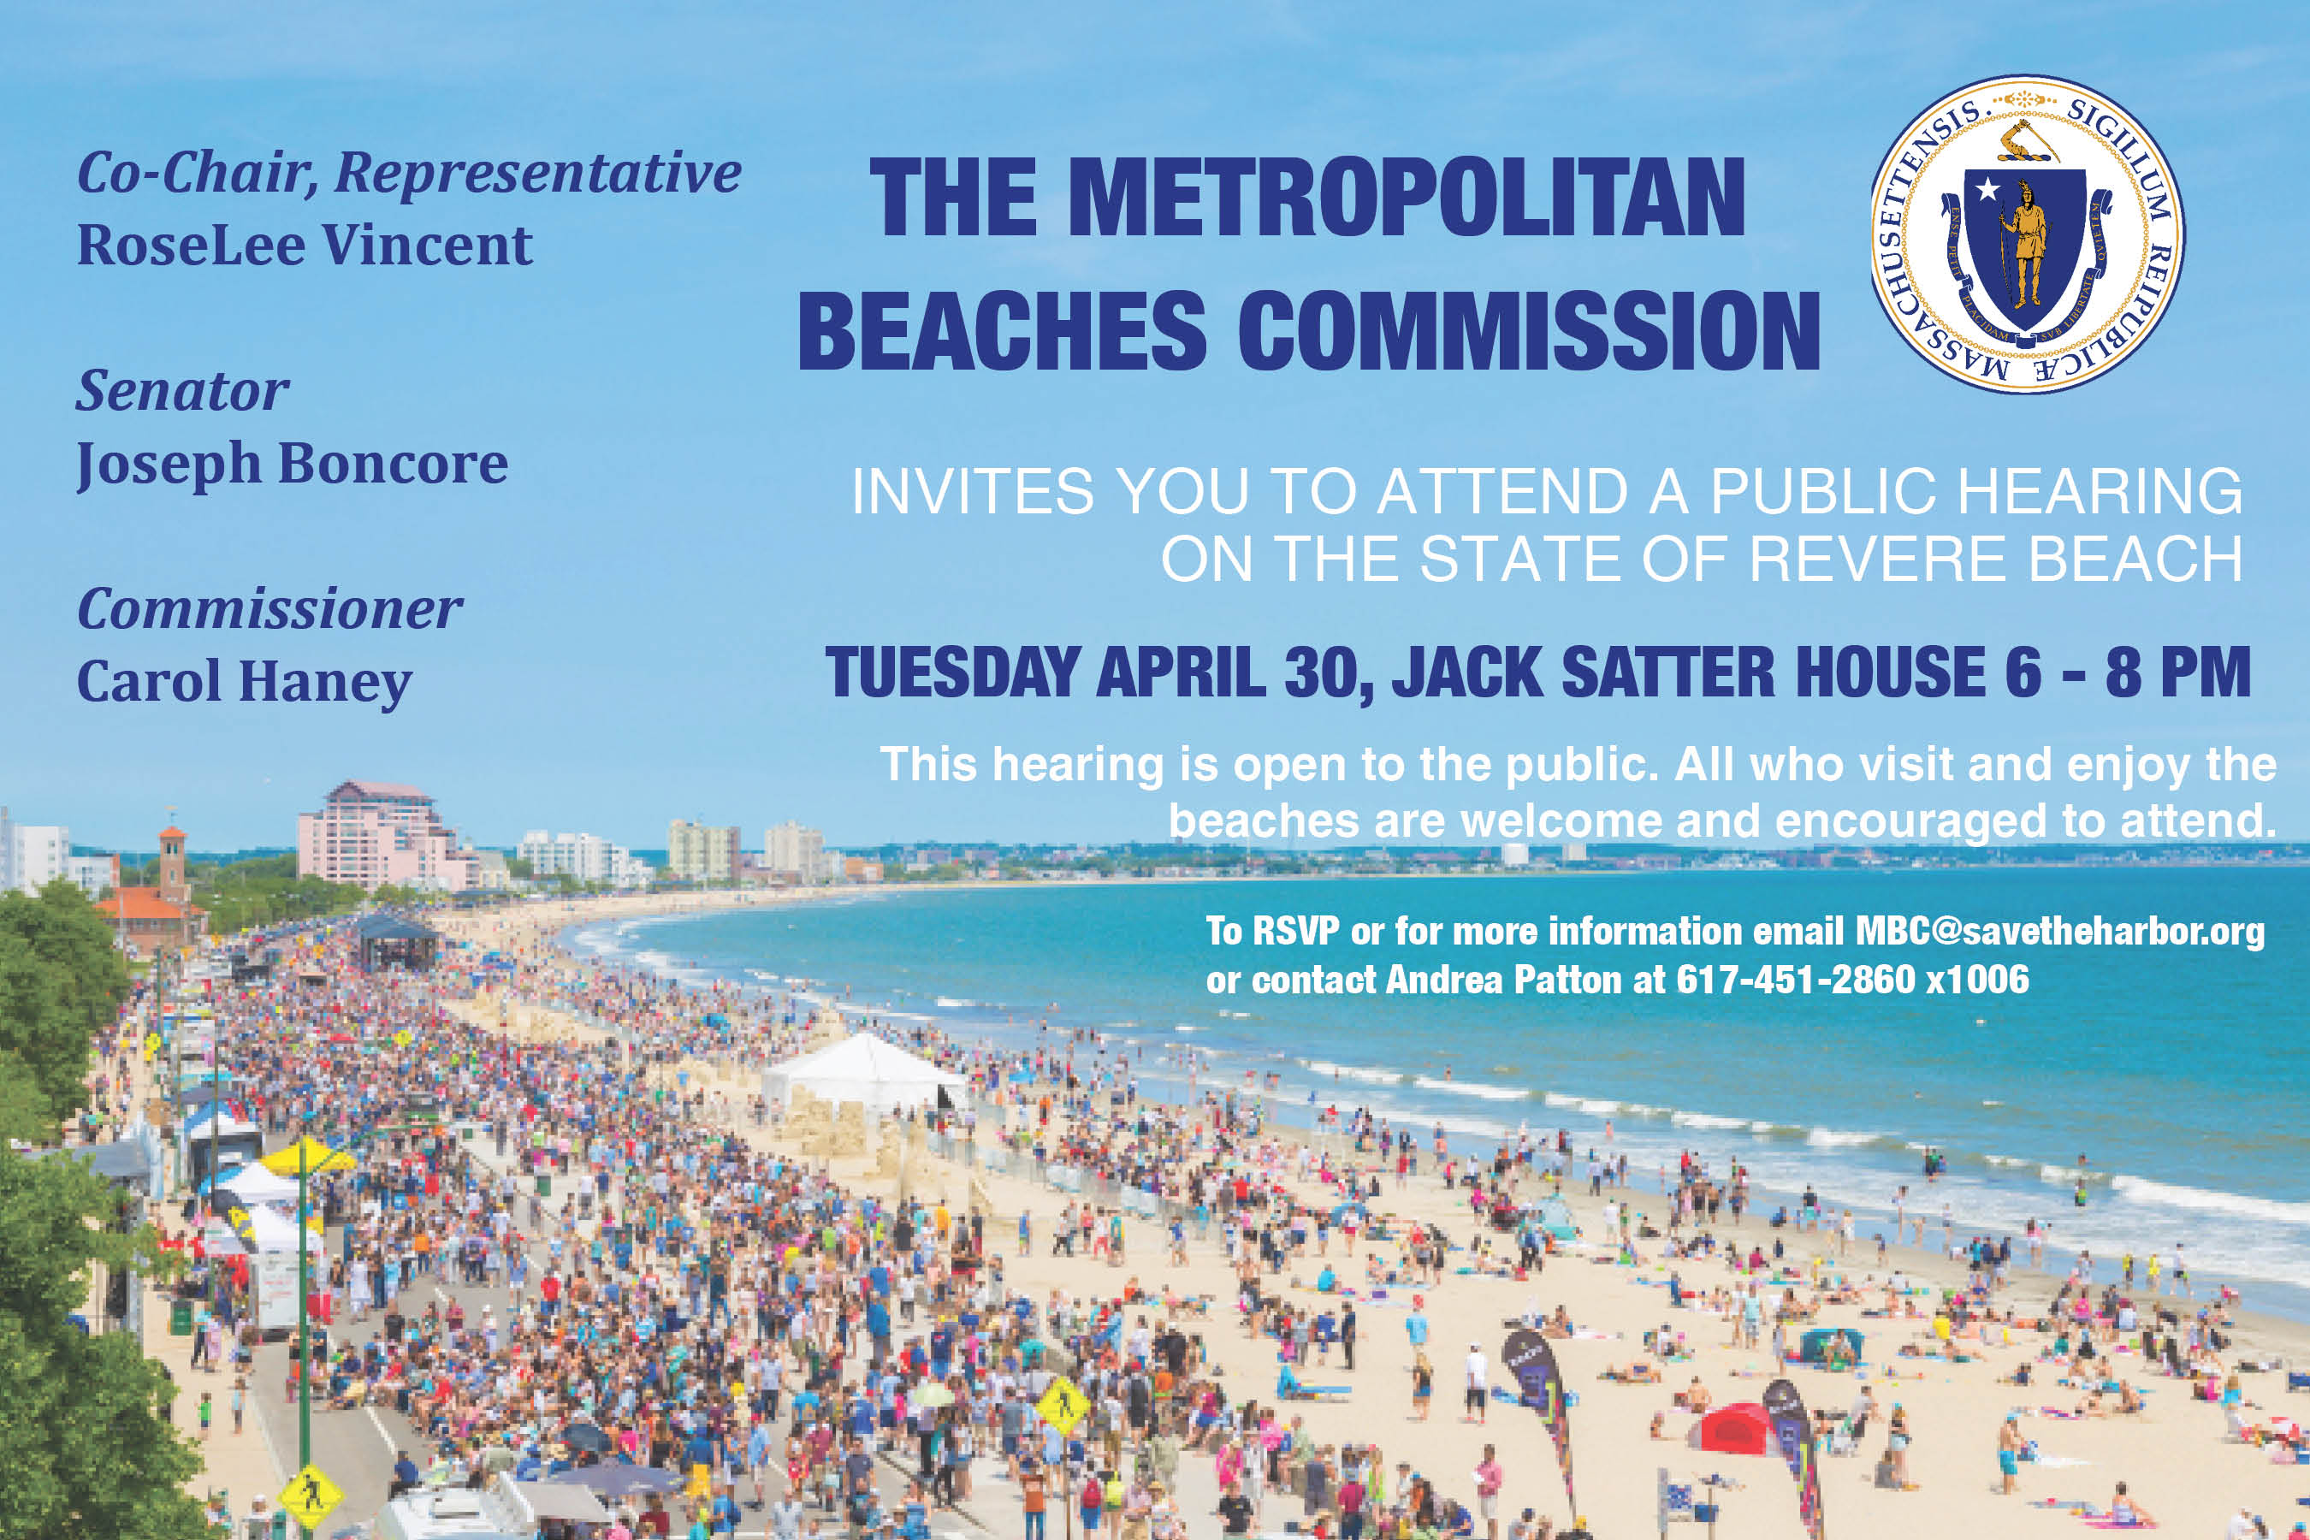

Landscaping, Upkeep, and Maintenance
- Participants appreciate DCR’s cleaning and landscaping work
  - Some attendees expressed that the sand raking could be improved
- The historic light poles are a favorite feature of the beach, but participants feel they need better maintenance, paint, etc. and would like to see the hanging baskets come back.
- Residents want to see better sidewalk cleaning on both sides of Revere Beach Blvd.
- There are consistent locations that get graffitied that need to be cleaned.
- Beach lovers would like to have a phone number for maintenance requests posted particularly at the bathrooms and rinsing stations.
- People expressed concerns about surf clams and a desire never to have marine mammals buried on the beach.
- There were many concerns about trash including requests for more barrels, more frequent pick up, seagull proof cans, and a desire to see restaurants do more trash pick up and move away from Styrofoam and other environmentally un-friendly containers.

Transportation, Traffic, and Parking
- Participants appreciate the public transportation access, although they would like to see a bus or shuttle that runs the length of the beach on Revere Beach Blvd.
- Beach goers are concerned about traffic safety on Revere Beach Blvd. especially with pedestrian crossings. Residents expressed frustration with traffic congestion stemming from commuters parking for free all day.
  - Many residents expressed a desire for significantly improved traffic management plans for the Sand Sculpting Festival.
  - A couple of attendees made specific traffic management requests including larger stop signs, longer signals etc. at specific intersections.
- Several participants expressed a desire for dedicated bike lanes and electric vehicle charging stations.
- Most attendees like the 10pm parking ban in “quiet zones” during the summer.
- Opinion was split on whether parking enforcement and towing efforts are sufficient, and similarly evenly split on whether paying for parking was a good or bad idea.

Activities, Open Space, and Amenities
- Beach goers very much appreciate the movie nights and Sand Sculpting Festival and would like to see more events, entertainment facilities, and family amusements such as arcade games.
  - One group noted that new activities could include revenue generating ideas such as rentals or a space modeled on the Lawn on D in Boston.
- Participants would like to see more park-like spaces and amenities including trees, grass, shade structures, picnic tables, a playground, and cooling stations.
- Beach goers also expressed a desire for more food options including more diverse restaurants, food trucks and carts, as well as retail including rentals, vendors, and shops for beach needs like towels and swim suits.

Beach Management
- Many participants commented on the rules regarding dogs – people mostly appreciate the off season rule (at least one person wants it changed from April 1 to May 1) but want to see better enforcement, more disposal bags, and perhaps a dedicated area.
- Attendees were split on whether they were happy with the piping plovers management efforts or frustrated with the impact on beach goers’ ability to use the beach
- People appreciate the increased police patrols and are fans of the lifeguards.
  - That said, people want to see more police presence including at the T station full time, new emergency phone stations, and more lifeguards at Elliot Circle.
- People appreciate having free public bathrooms and that they are kept clean, but would like them open later (both in terms of hours and seasons).

Other
- Everyone appreciates the great water quality at Revere Beach.
- The groups were split on whether they view the recent residential and mixed used developments along the waterfront positively.

